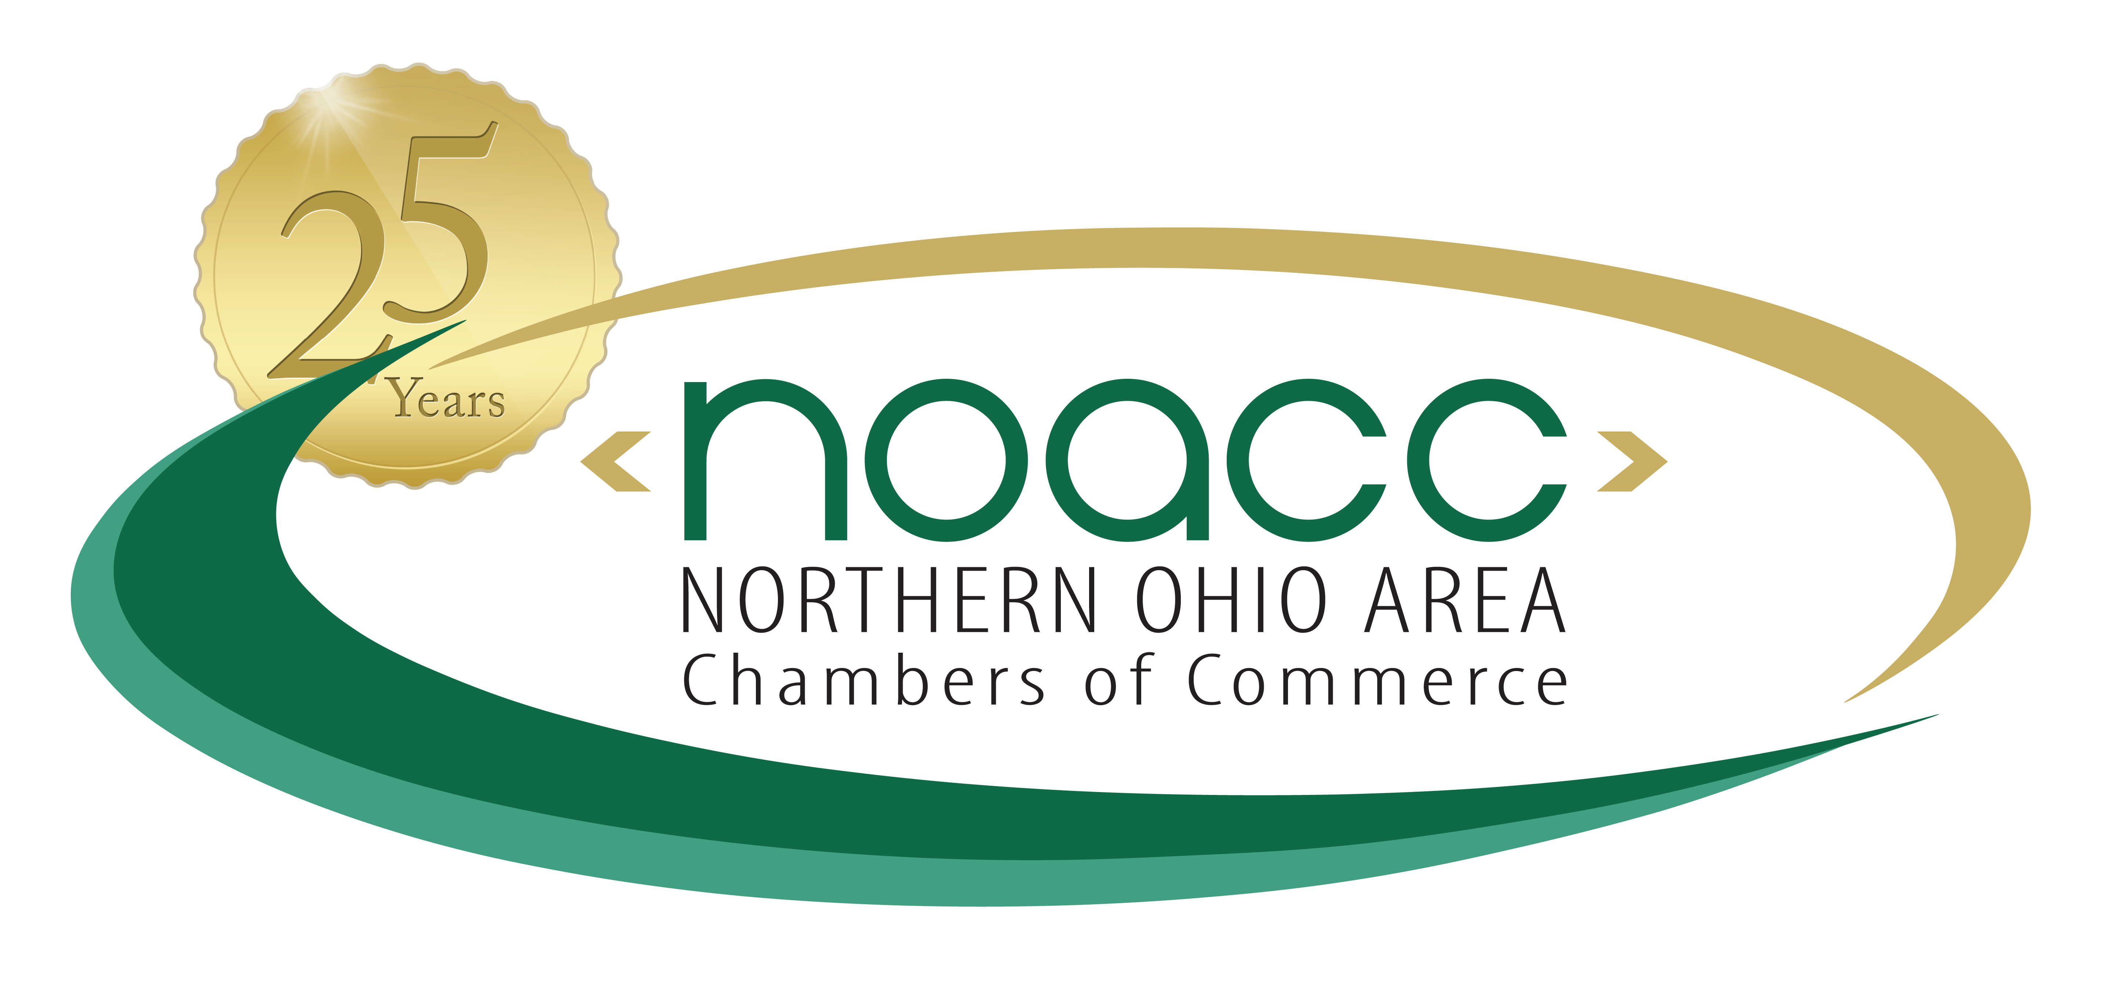
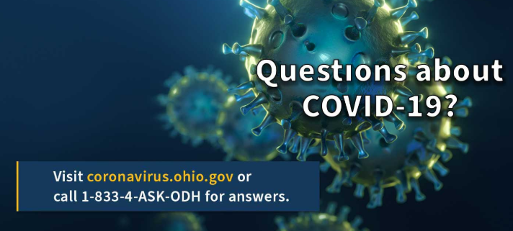

COVID-19 Past News Updates

- 6/16/20 - Basic Reproduction Number, Pop-Up Sites, Multi-System Youth Grant
- 6/16/20 - Director's Orders that Reopens Fairs and Animal Exhibitions, with Exceptions
- 6/16/20 - Minority Health Testing
- 6/11/20 - Executive Order - The Emergency Adoption, Amendment and Rescission of the OH Administrative Code Rules by the Ohio Department of Medicaid
- 6/11/20 - Testing Expansion, R0 in Ohio, Place of Worship Best Practices, New Role for Dr. Acton, ODJFS Employment/Training Gran
- 6/10/20 - COVID-19 Minority Health Strike Force
- 6/08/20 - Directors Amended Order that Reopens Restaurants, Bars, Banquet and Catering Facilities
- 6/05/20 - Additional Reopening Dates, Order Signed, Ohio National Guard
- 6/05/20 - Third Amended Director's Order to Limit Access to Ohio's Nursing Homes and Similar Facilities
- 6/04/20 - Director's Orders that Reopen Youth Day Camps and Residential Camps, with Exceptions
- 6/04/20 - Governor Announces Orders To Reopen Certain Facilities
- 6/02/20 - Disparity, K-12 Reopening, Medical Procedures, Funding Opportunities for Businesses
- 6/02/20 - Director's Order that Amends Requirements for Non-Essential Surgeries and Procedures
- 5/30/20 - Director's Order that Reopens Facilities Providing Child Care Services, with Exceptions
- 5/29/20 - Governor Announces New Health Orders Signed 5/29
- 5/29/20 - Director's Updated and Revised Order for Business Guidance and Social Distancing
- 5/29/20 - Director's Order that Rescinds the Sale of Spirituous Liquor be Restricted in Certain Instances
- 5/28/20 - Testing, Assisted Living Visitation, Premium Deferrals, Fairs
- 5-28-20 Bureau extends premium due date until September 1st
- 5/26/20 - Congregate Care Unified Response Teams
- 5/22/20 - Governor Announces New Health Orders Signed 5/22
- 5/22/20 - Order on Sports Activities
- 5/22/20 - Order to Open Gyms, Dance Studios and Other Personal Fitness Venues - with Exceptions
- 5/22/20 - Third Amendment K-12 Order
- 5/21/20 - Efforts to Improve Minority Health, New Sector Openings
- 5/20/20 - Governor Announces New Health Orders Signed
- 5/20/20 - COVID-19 Minority Health Strike Force Report
- 5/19/20 - Ohioans Protecting Ohioans Urgent Health Advisory
- 5/18/20 - Safety Checks, Twin Valley Update, Veterans Home Update
- 5/14/20 - New Responsible RestartOhio Opening Dates
- 5/14/20 - Directors Dine Safe Ohio Order
- 5/14/20 - Directors Order that Reopens Personal Services
- 5/12/20 - Pandemic EBT, Additional Services to Reopen, Staying Connected
- 5/12/20 - Advisory Groups
- 5/07/20 - Reopening of Restaurants, Bars, and Personal Care Services
- 5/07/20 - Hair Salons, Day Spas, Nail Salons, Barbershops & Tanning Facilities - Can reopen May 15th
- 5/07/20 - Executive Order - Balancing the State Budget
- 5/07/20 - Advisory Groups
- 5/06/20 - Job Opportunity - COVID-19 Contact Tracing
- 5/05/20 - State Budget Impact
- 5/04/20 - Testing Priority, Ohio BMVs
- 5/01/20 - Advisory Groups on Restaurants, and Personal Services
- 5/01/20 - Advisory Groups

- 4/30/20 - Directors Stay Safe Ohio Directive - Stay At Home Order Extended to May 29th
- 4/30/20 - Prison PPE, ODRC Update
- 4/29/20 - PPE Delivery, Employee Face Covering Exceptions, Criminal Justice Grants, Class of 2020 Graduation
- 4/29/20 - Second Amended Order the Closure of All K-12 Schools in the State of Ohio
- 4/29/20 - Guidance for Graduation Ceremonies
- 4/28/20 - Face Coverings, Advisory Groups on Restaurants, Barbershops, and Salons
- 4/27/20 - Praise for Governor DeWine's Responsible RestartOhio Plan
- 4/27/20 - Governor DeWine Announces Details of Ohio's Responsible RestartOhio Plan
- 4/26/20 - ODH | Find Local Health Districts
- 4/25/20 - Reagent and Testing Swabs, Contact Tracing, Foster Care
- 4/23/20 – How Environmental Changes Impact Health Risk
- 4/22/20 –Elective Surgery Order, Mental Health CareLine
- 4/21/20 – FDA Reagent Approval, Testing Strike Team, Fair Wavier, JobsOhio Banking Partnership, Dividend Checks
- 4/20/20 – K-12 Schools to Remain Closed, Minority Health Strike Force, Data Collection, Private Lab Testing
- 4/20/20 – Order Allowing Testing to Resume at Non-Hospital Labs
- 4/20/20 – Minority Health Strike Force
- 4/17/20 – Update: Recovery Phase, Inmate Testing
- 4/17/20 – The Path Forward to Restart Graphic
- 4/16/20 – Governor DeWine Discussed State’s Plan for Reopening Businesses, Regional Coalition Formed
- 4/15/20 – Deferred Elective Procedures, CARES Act Payments, 1099 Unemployment Claims, First Responder PPE, Testing Partnership, Prison Update, Census 2020
- 4/15/20 – In This Together Ohio Logo (PDF) and Graphic (JPEG)
- 4/14/20 – Director’s Order to Facilities to Notify Residents, Guardians and Sponsors of Positive or Probable Cases
- 4/14/20 – Medicaid Waiver Application, First Responder Safety, Essential Job Openings
- 4/13/20 – Antibody Test Kits – COVID-19 Information and Checklist
- 4/13/20 – COVID-19 Update: Nursing Home Order, Liquor Sales, TANF Funding, Rapid Testing, Prison Update
- 4/13/20 – Order that the Sale of Spirituous Liquor be Restricted in Certain Instances in Certain Counties
- 4/10/20 – Executive Order 2020-13D
- 4/10/20 – Executive Order 2020-12D
- 4/10/20 – COVID-19 Ask the Expert: Anthony J. Armstrong
- 4/10/20 – COVID-19 Update: Eased Medicaid Restrictions, N95 Sterilization, Distillery-Made Hand Sanitizer, Food Trucks at Rest Areas, New Data Reporting
- 4/09/20 – COVID-19 Update: PPE Manufacturing, Convalescent Plasma
- 4/09/20 – Convalescent Plasma to Treat COVID-19 COVID-19 Checklist
- 4/08/20 – COVID-19 Update: Continue Staying Home, Correction Officer Death, PPE Sterilization, Child Abuse Reports, Proposed $1.6 Million Dividend for Employers
- 4/07/20 – Sites Selected for Enhanced Hospital Capacity; Ohio National Guard to Assist Federal Prison; Dispute Resolution Commission Now Active
- 4/07/20 – Cloth Face Coverings (Masks) COVID-19 Checklist
- 4/07/20 – COVID-19 Update: Liquor Sales, Office of Small Business Relief, Ohio Prisons, SNAP Payments
- 4/05/20 - Ohioans Encouraged to Wear Cloth Masks in Public; Governor Signs TeleHealth Executive Order; New Wi-Fi Hotspot Locator
- 4/03/20 - COVID-19 Update: Testing Supplies; PPE Sanitizing; Inmate Release Recommendation; Remote Learning Guide
- 4/02/20- Ohio Stay at Home Order Extended Through May 1
- 4/01/20 - Hospital Preparedness Regions and Healthcare Zones
- 4/01/20 - Order for Performing COVID-19 Testing
- 4/01/20 - Slides from Governor's Press Conference
- 3/31/20 - Ohio Takes Inventory of Ventilators; Issues Emergency Connection Order; Extends State Telework Order
- 3/30/20 - Governor DeWine Extends School Closure Order
- 3/30/20 - Slides from 3/30 Press Conference
- 3/30/20 - Governor DeWine, Lt. Governor Husted Thank FDA for Approval of Use of Battelle Technology
- 3/29/20 - Together Ohio Website
- 3/29/20 - Governor DeWine, Lt. Governor Husted Express Disappointment in FDA's Decision to Limit Use of Battelle Technology
- 3/29/20 - Governor DeWine Makes Plea to FDA; Releases List of Needed PPE
- 3/27/20 - Slides from 3/27/20 Press Conference
- 3/27/20 - Governor DeWine Signs House Bill 197
- 3/26/20 - Acting Secretary Chad Wolf Statement on the REAL ID Enforcement Deadline
- 3/26/20 - Personal Protective Equipment Needed; New COVID-19 Data Dashboard Unveiled
- 3/26/20 - Amended Director's Order to Close Facilities Providing Older Adult Day Care Services and Senior Centers
- 3/26/20 - Personal Protective Equipment Needed; New COVID-19 Data Dashboard Unveiled
- 3/25/20 - Requests for our Federal Partners
- 3/25/20 - Director’s Order to Close Facilities Providing Child Care Services
- 3/24/20 - Slides from 3/24 Press Conference - Link
- 03/23/20 - Governor DeWine Orders Hiring Freeze for State Agencies, Boards, and Commissions - Link
- IR-2020-57: Treasury, IRS and Labor announce plan to implement Coronavirus-related paid leave for workers and tax credits for small and midsize businesses
- 3/22/20 - Stay At Home Order Frequently Asked Questions
- 03/22/20 - Ohio Issues "Stay at Home" Order; New Restrictions Placed on Day Cares for Children (Español)
- 03/21/20 - Day Support for Developmentally Disabled to Close; BWC Payments Deferred; Trucking Waiver Issued (Español)
- 03/20/20 - Ohio Records First COVID-19 Death; Senior Centers, Adult Day Cares to Close - Link
- 03/19/20 - Applications Being Accepted for Economic Injury Disaster Loan Program; Governor DeWine Signs Order Expanding Telehealth Services for Medicaid Recipients
- 3/18/20 - IRS - Payment Deadline Extended to July 15, 2020 - Link
- 3/18/20 - Gov. DeWine closes BMVs, salons; Asks employers to take temperatures - Link
- 3/18/20 - President Trump invokes act to marshal private sector against virus; announces suspension of foreclosures, evictions. Link
- 3/18/20 - Tonight, Gov. Mike DeWine and Health Director Dr. Amy Acton are sitting down to answer questions and tell you how to protect yourself and your family during this time. www. Fox8.com
- 03/18/20 - Governor DeWine, Lt. Governor Husted Submit Formal Request for Federal Assistance for Small Businesses - Link
- 03/17/20 - Elective Surgeries Postponed in Ohio Hospitals - Link (Español)
- 03/17/20 - Joint Statement from Governor DeWine and Secretary LaRose on Primary Election Lawsuits - Link
- 03/16/20 - Statement from Ohio Governor Mike DeWine on the March 17, 2020 Election - Link (Español)
- 03/16/20 - Joint Statement from Governor DeWine and Secretary LaRose on Ohio Primary - Link (Español)
- 03/13/20 - Governor DeWine Provides COVID-19 Update - Link
- 03/15/20 - Governor DeWine Orders Ohio Bars & Restaurants to Close - Link
- 03/12/20 - Ohio Bans Mass Gatherings of 100 or More - Link
- 03/12/20 - Governor DeWine 3-12-2020 COVID-19 Update (Video) Link
- 03/12/20 - Governor DeWine Announces School Closures - Link
- 03/10/20 - Governor DeWine Recommends Limiting Large Indoor Gatherings - Link
- 03/09/20 - Governor DeWine Signs Emergency Order Regarding Coronavirus Response - Link
- 03/09/20 - Governor Mike DeWine - Update on State Response to Coronavirus - Link
- 03/09/20 - Governor, Health Director Announce COVID-19 Testing Protocol - Link
- 02/27/20 - Governor DeWine, Health Director Update COVID-19 Prevention and Preparedness Plan - Link

